**Maths - Core 3 Coursework**

**Change of Sign – Decimal Search Method**

**The "Change of Sign – Decimal Search" method involves the finding of roots due to a change of sign in the values of the f(). As the curve crosses the -axis, the f() changes sign provided that the f() is a continuous function. Once you have located an interval in which the f() changes sign, you then know that a root must lie in the interval.**

**Below is the graph showing the function**

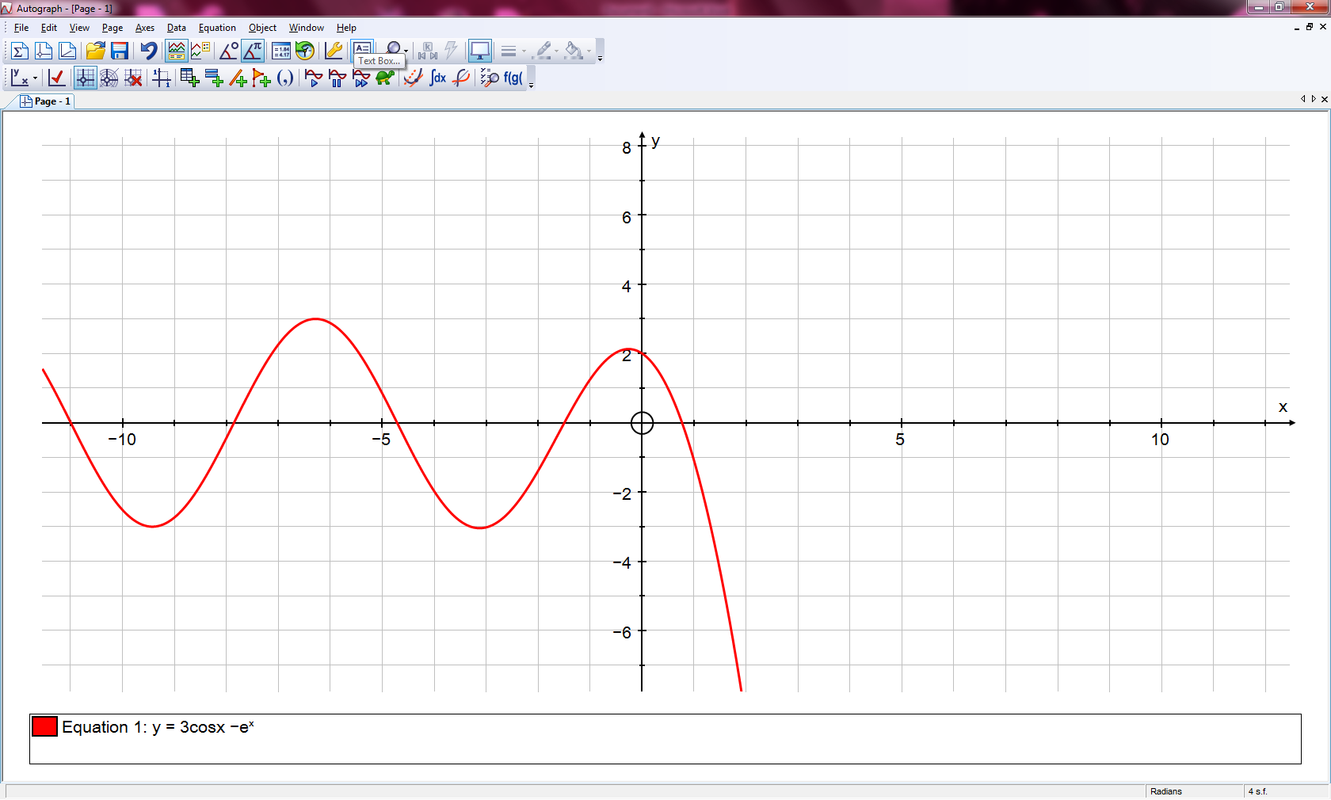

**I will find the root between 0 and 1 using this method.**

The root I am looking for, when it crosses the x-axis is in the interval [0, 1]

|  |  |
| --- | --- |
| **x** | **f(x)** |
| **-5** | **0.844249** |
| **-4** | **-1.97925** |
| **-3** | **-3.01976** |
| **-2** | **-1.38378** |
| **-1** | **1.253027**  Here there are two cases where the f() has a clear sign change: One in the interval of [-5,-4] and the other in the interval [0, 1]. I will be searching for the root in the interval [0, 1] |
| **0** | **2** |
| **1** | **-1.09737** |
| **2** | **-8.6375** |
| **3** | **-23.0555** |
| **4** | **-56.5591** |
| **5** | **-147.562** |

|  |  |
| --- | --- |
| **x** | **f(x)** |
| **0** | **2** |
| **0.1** | **1.879842** |
| **0.2** | **1.718797** |
| **0.3** | **1.516151** |
| **0.4** | **1.271358** |
| **0.5** | **0.984026** |
| **0.6** | **0.653888** |
| **0.7** | **0.280774** |
| **0.8** | **-0.13542** |
| **0.9** | **-0.59477** |
| **1** | **-1.09737** |

A sign change occurs again in the interval [0.7, 0.8] meaning it has crossed the -axis somewhere between these points.

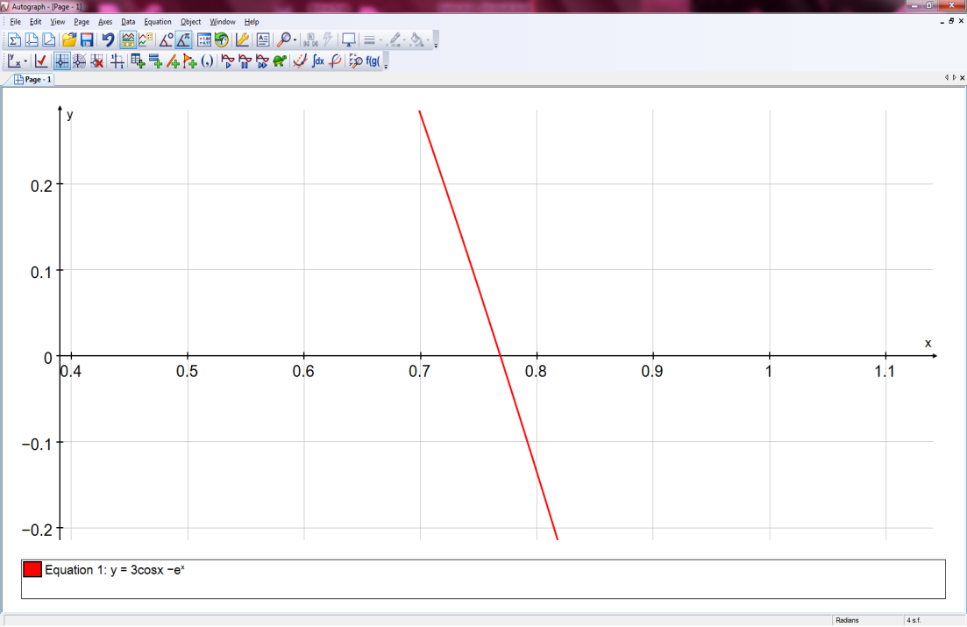

|  |  |
| --- | --- |
| **x** | **f(x)** |
| **0.70** | **0.280774** |
| **0.71** | **0.241094** |
| **0.72** | **0.200984** |
| **0.73** | **0.160443** |
| **0.74** | **0.11947** |
| **0.75** | **0.078067** |
| **0.76** | **0.036232** |
| **0.77** | **-0.00603** |
| **0.78** | **-0.04873** |
| **0.79** | **-0.09186** |
| **0.80** | **-0.13542** |

Sign change again in the interval [0.76, 0.77]

|  |  |
| --- | --- |
| **x** | **f(x)** |
| **0.760** | **0.03623181** |
| **0.761** | **0.03202461** |
| **0.762** | **0.0278131** |
| **0.763** | **0.02359728** |
| **0.764** | **0.01937715** |
| **0.765** | **0.0151527** |
| **0.766** | **0.01092394** |
| **0.767** | **0.00669086** |
| **0.768** | **0.00245347** |
| **0.769** | **-0.0017882** |
| **0.770** | **-0.0060342** |

A sign change has occurred again and is illustrated by the graph in the interval [0.768, 0.769]

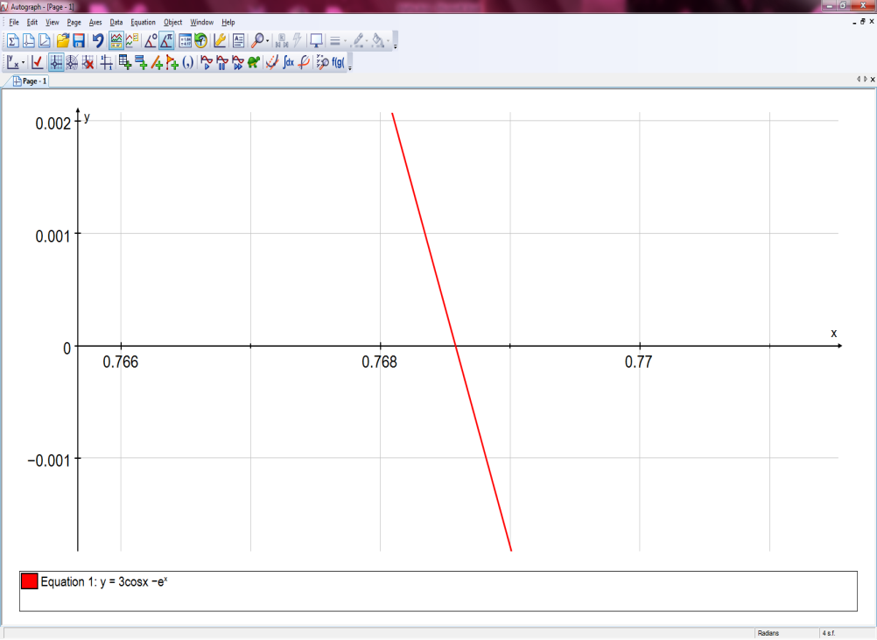

|  |  |
| --- | --- |
| **x** | **f(x)** |
| **0.7680** | **0.002453** |
| **0.7681** | **0.002029** |
| **0.7682** | **0.001605** |
| **0.7683** | **0.001181** |
| **0.7684** | **0.000757** |
| **0.7685** | **0.000333** |
| **0.7686** | **-9.1E-05** |
| **0.7687** | **-0.00052** |
| **0.7688** | **-0.00094** |
| **0.7689** | **-0.00136** |
| **0.7690** | **-0.00179** |

This is the value of () I obtain to 5 decimal places using the "**Change of Sign – Decimal Search**” method.

Therefore, the root to 5 D.P. is:

**= 0.76855 ± 0.00005**

**Where there ± 0.00005 is the error bound**

**Examples of Change of Sign – Decimal Search Failure**

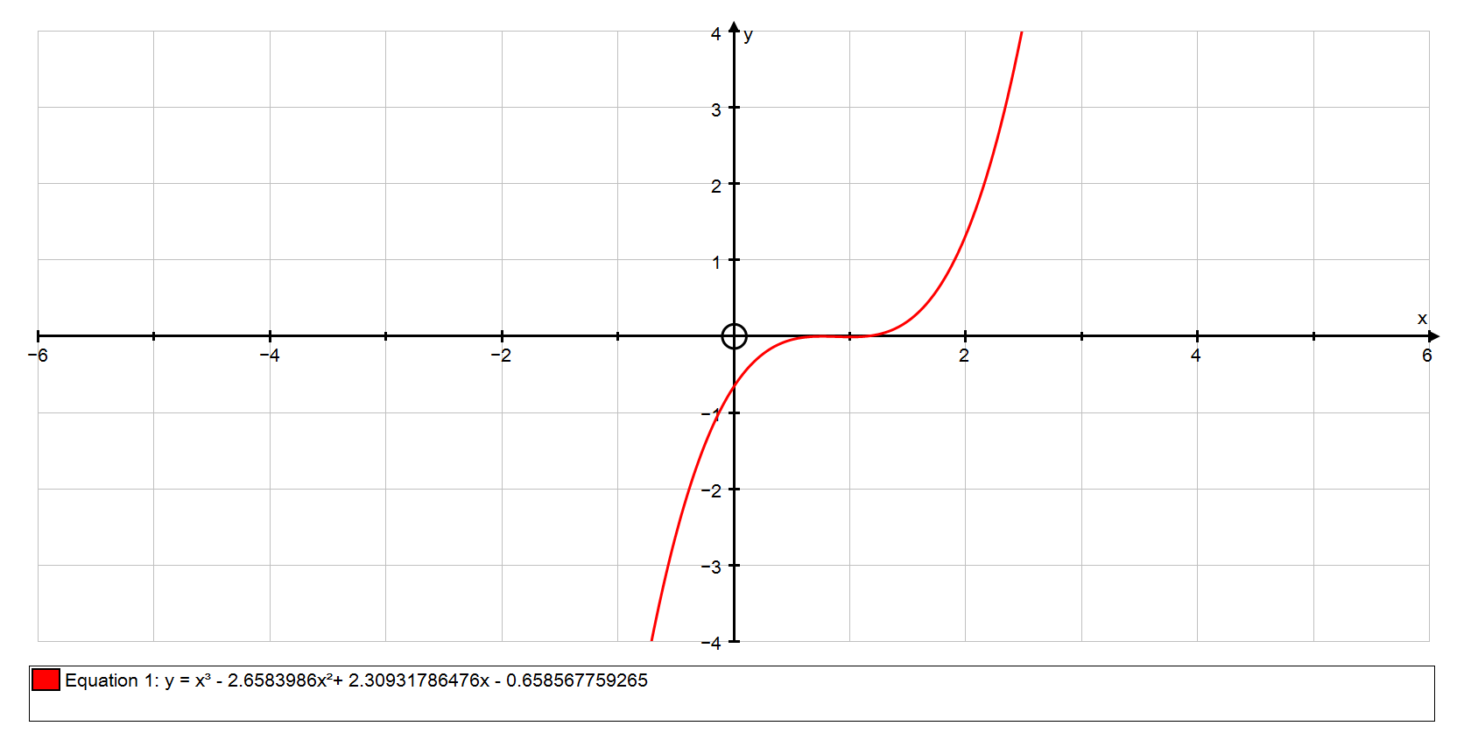**There are cases, however, where the "Sign Change" method fails.**

**Below is one case:**

**An image showing the graph of the function:**

Here the graph crosses the -axis just momentarily between 0 and 1 before crossing back again in the same interval.

However, in this table of results, no sign change appears indicating that the method has failed.

**I will attempt to find the roots in the interval [0, 1].**

|  |  |
| --- | --- |
| **x** | **f(x)** |
| **-5** | **-203.6651221** |
| **-4** | **-116.4302168** |
| **-3** | **-58.51210875** |
| **-2** | **-23.91079789** |
| **-1** | **-6.626284224** |
| **0** | **-0.658567759** |
| **1** | **-0.007648495** |
| **2** | **1.32647357** |
| **3** | **9.343798435** |
| **4** | **30.0443261** |
| **5** | **69.42805656** |

However, in this table of results, no sign change appears indicating that the method has failed.

|  |  |
| --- | --- |
| **x** | **f(x)** |
| **0** | **-0.658567759** |
| **0.1** | **-0.453219959** |
| **0.2** | **-0.29504013** |
| **0.3** | **-0.178028274** |
| **0.4** | **-0.096184389** |
| **0.5** | **-0.043508477** |
| **0.6** | **-0.014000536** |
| **0.7** | **-0.001660568** |
| **0.8** | **-0.000488571** |
| **0.9** | **-0.004484547** |
| **1** | **-0.007648495** |

Taking a closer look into the interval [0, 1]; we see that still there is no sign change. However, we do see that the interval [0.7, 0.8] holds smaller numbers than the rest indicating a root may be here.

|  |  |
| --- | --- |
| **x** | **f(x)** |
| **0.7** | **-0.001660568** |
| **0.71** | **-0.00113981** |
| **0.72** | **-0.000724731** |
| **0.73** | **-0.000409332** |
| **0.74** | **-0.000187613** |
| **0.75** | **-5.35732E-05** |
| **0.76** | **-1.21341E-06** |
| **0.77** | **-2.45333E-05** |
| **0.78** | **-0.000117533** |
| **0.79** | **-0.000274212** |
| **0.8** | **-0.000488571** |

Taking a closer look into the interval [0, 1]; we see that still there is no sign change. However, we do see that the interval [0.7, 0.8] holds smaller numbers than the rest indicating a root may be here.

|  |  |
| --- | --- |
| **x** | **f(x)** |
| **0.7** | **-0.001660568** |
| **0.71** | **-0.00113981** |
| **0.72** | **-0.000724731** |
| **0.73** | **-0.000409332** |
| **0.74** | **-0.000187613** |
| **0.75** | **-5.35732E-05** |
| **0.76** | **-1.21341E-06** |
| **0.77** | **-2.45333E-05** |
| **0.78** | **-0.000117533** |
| **0.79** | **-0.000274212** |
| **0.8** | **-0.000488571** |

However, when taking a closer inspection of the [0.7, 0.8] interval, we see that the method has still failed to note a sign change.

Therefore, the “Change of Sign – Decimal Search” method has failed as it does not indicate that there are any roots in the interval [0, 1] when there is illustrated in the graphs to the left.

However, when taking a closer inspection of the [0.7, 0.8] interval, we see that the method has still failed to note a sign change.

Therefore, the “Change of Sign – Decimal Search” method has failed as it does not indicate that there are any roots in the interval [0, 1].

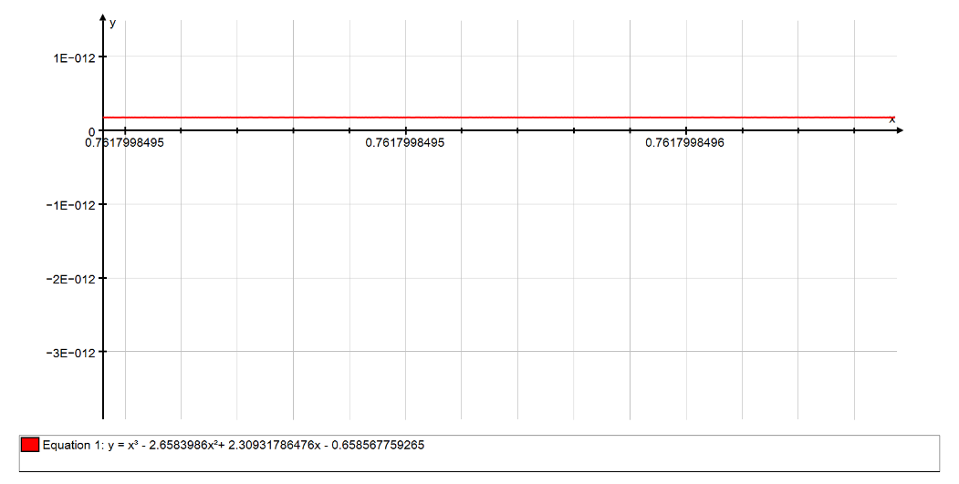

Line f(x) is above the x-axis here.

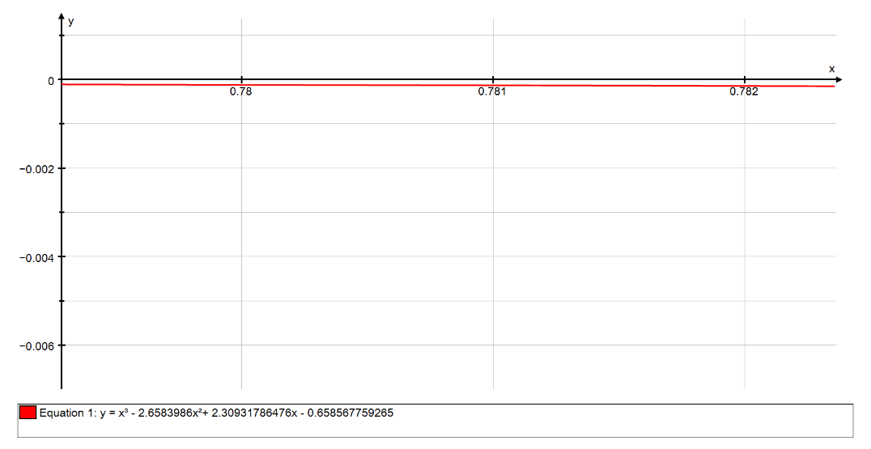

Line f(x) is below the x-axis here indicating it must have crossed the x-axis at some point.

**Fixed Point Iteration – Newton-Raphson Method**

**This numerical method works by first starting with an estimate, , for a root of f() = 0. You then draw a tangent to the curve of y = f() at the point ( , f() ) . The point at which the tangent cuts the x axis gives you the next approximation, . Then the process is repeated multiple times until we close onto the root and deduce a good approximation for it.**

**Below is the graph of function for which we will use the Newton’s Raphsons method to find all 3 roots.**

**I will find “Root 1” first.**

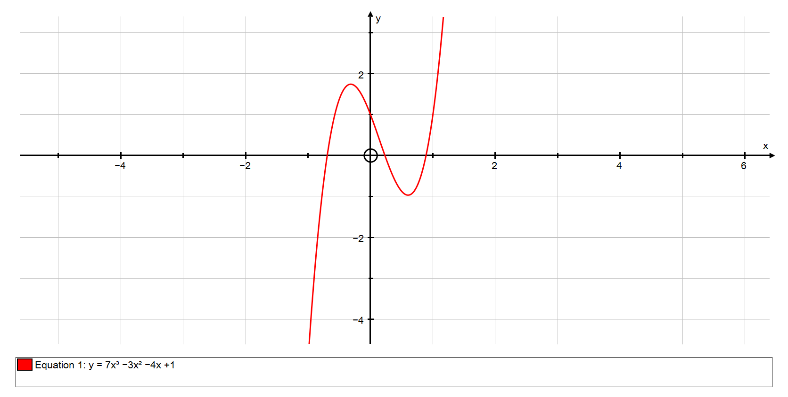**First we must make an estimate for. We know that “Root 1” must lie in the interval [0, 1] as the graph portrays it crossing the x-axis in that that interval. Therefore, my estimate will be that**  = 1 as it is quite close to the root we wish to find.

Root 3

Root 3

Root 1

Root 1

Root 2

Root 2

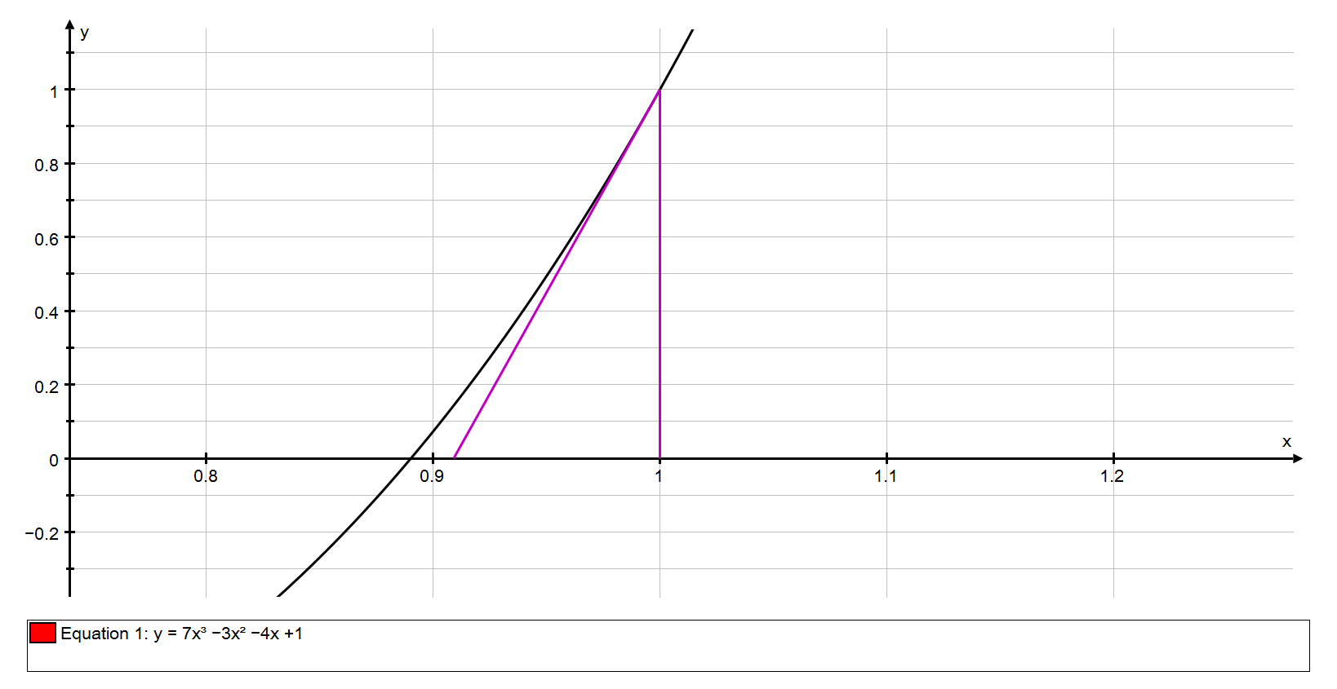Below is the graph showing the first iteration. We start from our point **, and draw a vertical line to the curve, y = f(x). The point where it meets the curve is (, f ()). We will then draw a tangent to the curve starting from this point to the x-axis where the point where it hits the x-axis is our new estimation for the root called .**

**Tangent to the curve at the point (, f ())**

**Tangent to the curve at the point (, f ())**

**(, f ())**

**(, f ())**

**Repeating this process we then reach our second approximation for the root which is as shown in the graph below.**

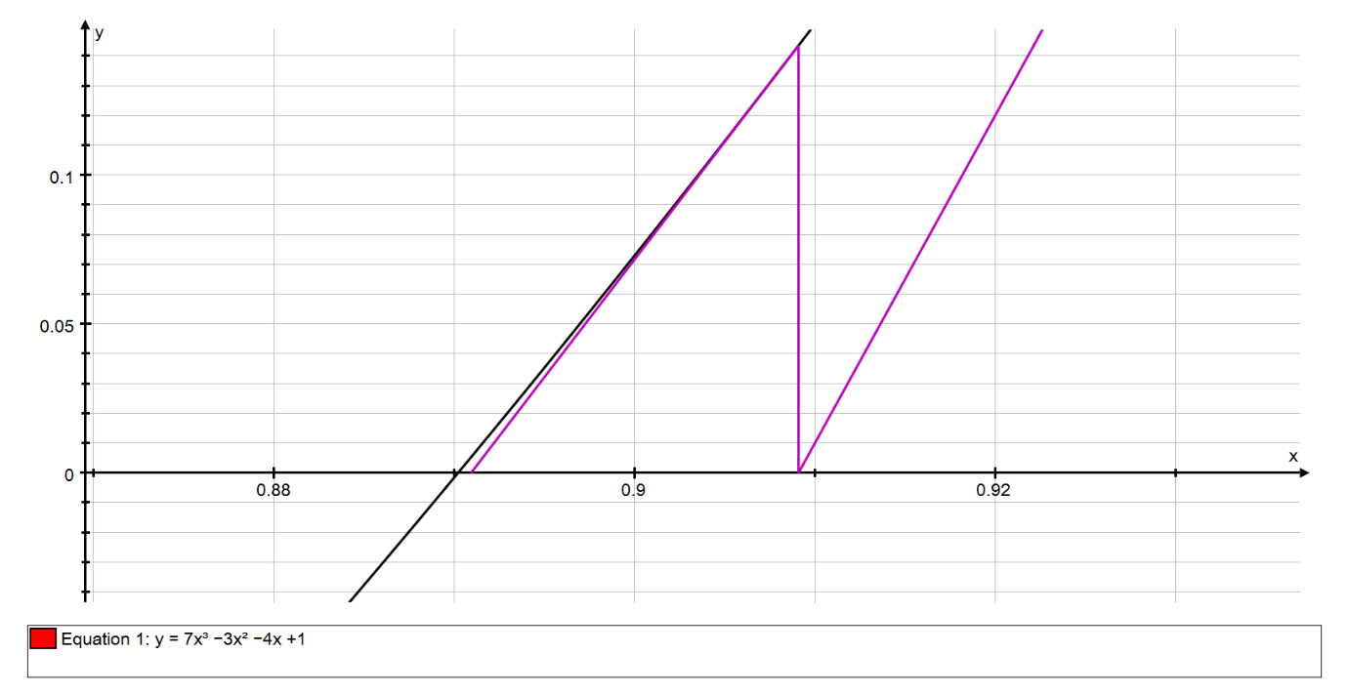**This process is then repeated until a suitable degree of accuracy is found.**

**Tangent to the curve at the point (, f ())**

**Tangent to the curve at the point (, f ())**

**(, f ())**

**(, f ())**

**The Newton-Raphson Iteration Formula is as follows:**



In order to find “Root 1”, we have to use out first estimate which was equal to 1 and the equation

So,

**21**

**Therefore, our new approximation =**

Repeating this process will result in the following:

**21**

**This results in our new approximation being:**

**= =**

|  |  |  |  |  |  |
| --- | --- | --- | --- | --- | --- |
| **x** | **f(x)** |  | **f'(x)** | **New x** |  |
| **1** | **1** |  | **11** | **0.909090909** |  |
| **0.909091** | **0.143501** |  | **7.900826** | **0.89092811** |  |
| **0.890928** | **0.005266** |  | **7.323242** | **0.890208996** |  |
| **0.890209** | **8.12E-06** |  | **7.300659** | **0.890207883** |  |
| **0.890208** | **1.94E-11** |  | **7.300624** | **0.890207883** |  |
| **0.890208** | **0** |  | **7.300624** | **0.890207883** |  |

**As you can see, the Newton-Raphson method converged to the root in only a few iterations. The root produced is 0.89021 ± 0.000005**

The root is, therefore, 0.89021 to 5 s.f. with an error bound of 0.000005

**Moving onto “Root 2”, we see that the root is closest to 0 and therefore, our first estimate would be . Then the table of results follow:**

|  |  |  |  |  |  |
| --- | --- | --- | --- | --- | --- |
| **x** | **f(x)** |  | **f'(x)** | **New x** |  |
| **0** | **1** |  | **-4** | **0.25** |  |
| **0.25** | **-0.07813** |  | **-4.1875** | **0.231343284** |  |
| **0.231343** | **0.000738** |  | **-4.26415** | **0.231516286** |  |
| **0.231516** | **5.57E-08** |  | **-4.2635** | **0.231516299** |  |
| **0.231516** | **0** |  | **-4.2635** | **0.231516299** |  |

**Here, the root produced is 0.23152 ± 0.000005** to 5.s.f

To prove that this is the root, you may check the root to see if there is a sign change if you put it into the function ).

There is a sign change so the root so  **0.23152 ± 0.000005.**

“Root 3” would result in the following table with our initial estimate as -1:

|  |  |  |  |  |  |
| --- | --- | --- | --- | --- | --- |
| **x** | **f(x)** |  | **f'(x)** | **New x** |  |
| **-1** | **-5** |  | **23** | **-0.7826087** |  |
| **-0.78261** | **-1.0623** |  | **13.55766** | **-0.70425447** |  |
| **-0.70425** | **-0.11595** |  | **10.64099** | **-0.6933579** |  |
| **-0.69336** | **-0.0021** |  | **10.2558** | **-0.69315283** |  |
| **-0.69315** | **-7.4E-07** |  | **10.24859** | **-0.69315275** |  |
| **-0.69315** | **-9.2E-14** |  | **10.24859** | **-0.69315275** |  |
| **-0.69315** | **0** |  | **10.24859** | **-0.69315275** |  |

**As you can see, the root, i.e. when the f(x) = 0, is**  **-0.69315 ± 0.000005** to 5 s. f.

**Example of Newton-Raphson Failure**

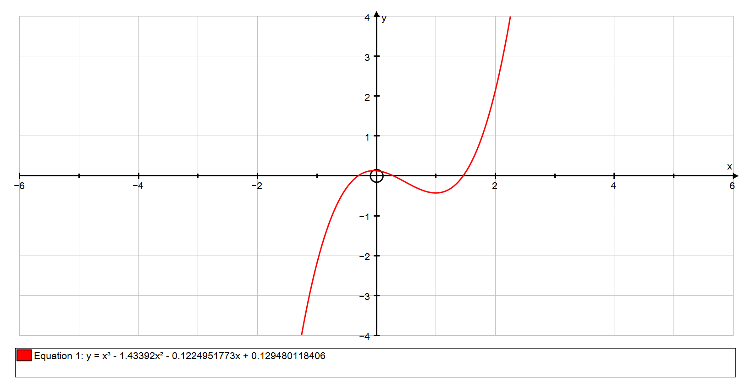**The Newton-Raphson method is also prone to failure as illustrated below with the function,**

**As we can see in the above graph, there are 3 roots: the first in the interval [1, 2], the second in the interval [0, 1] and the third in the interval [-1, 0].**

**I will attempt to use the Newton-Raphson method to converge to the root in the interval [0, 1] with our set as 0.**

**f(0) = =**

**f**

**So, =** 1.057022172

**The table that follows shows the sequence converging; however, it has converged to the wrong root. Instead of converging to the root we are looking for, the root in the interval [0, 1], it has converged to the root in the interval [1, 2]**

|  |  |  |  |  |  |
| --- | --- | --- | --- | --- | --- |
| **x** | **f(x)** |  | **f'(x)** | **New x** |  |
| **0** | **0.129480118** |  | **-0.122495177** | **1.057022172** |  |
| **1.057022172** | **-0.421106387** |  | **0.198021974** | **3.1835861** |  |
| **3.1835861** | **17.47275781** |  | **21.15315062** | **2.357574026** |  |
| **2.357574026** | **4.974501176** |  | **9.790825589** | **1.849496221** |  |
| **1.849496221** | **1.324460844** |  | **4.835354391** | **1.575584375** |  |
| **1.575584375** | **0.288155644** |  | **2.806379299** | **1.472905581** |  |
| **1.472905581** | **0.033633589** |  | **2.161799831** | **1.457347438** |  |
| **1.457347438** | **0.000718721** |  | **2.069650214** | **1.457000171** |  |
| **1.457000171** | **3.54279E-07** |  | **2.067609949** | **1.457** |  |
| **1.457** | **8.62921E-14** |  | **2.067608943** | **1.457** |  |
| **1.457** | **0** |  | **2.067608943** | **1.457** |  |

**Below shows the failure graphically:**

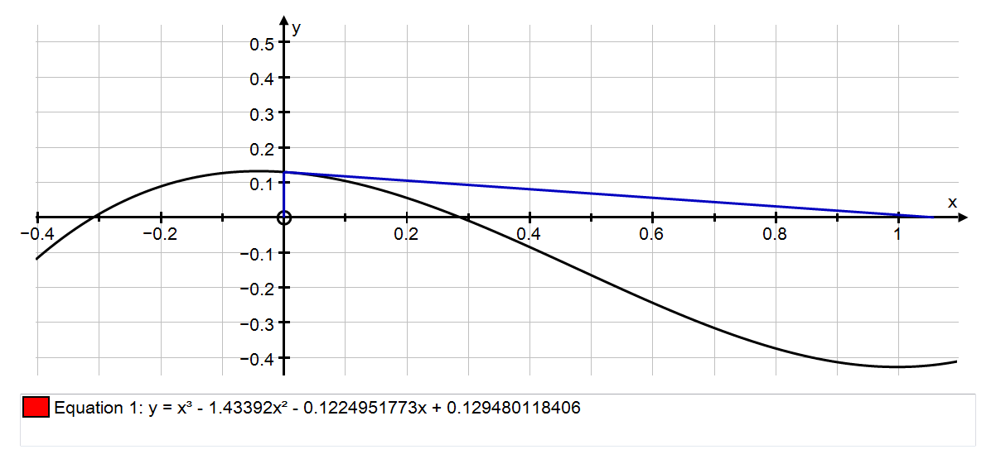

**Here, the tangent of the curve at y = f(x) at point forms by creating a tangent from the top of the curve to where it hits the x-axis instead of it normally creating a tangent from the bottom of the curve.**

**As we increase the amount of iterations, it is clear that the sequence has diverged from the original root we set off to find; instead it converges in onto another root.**

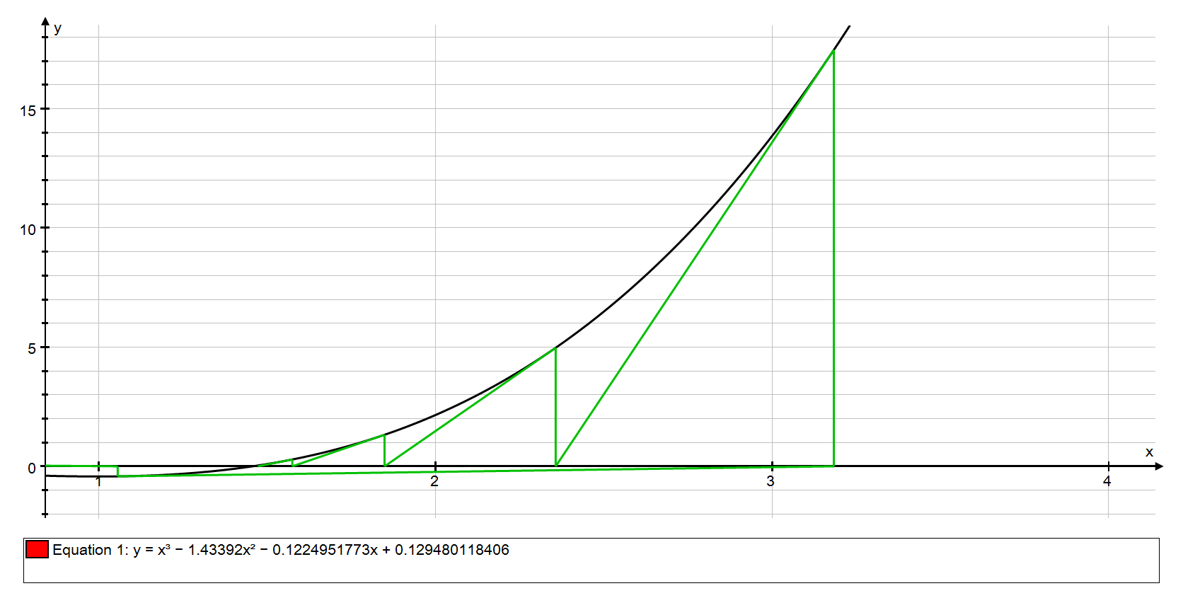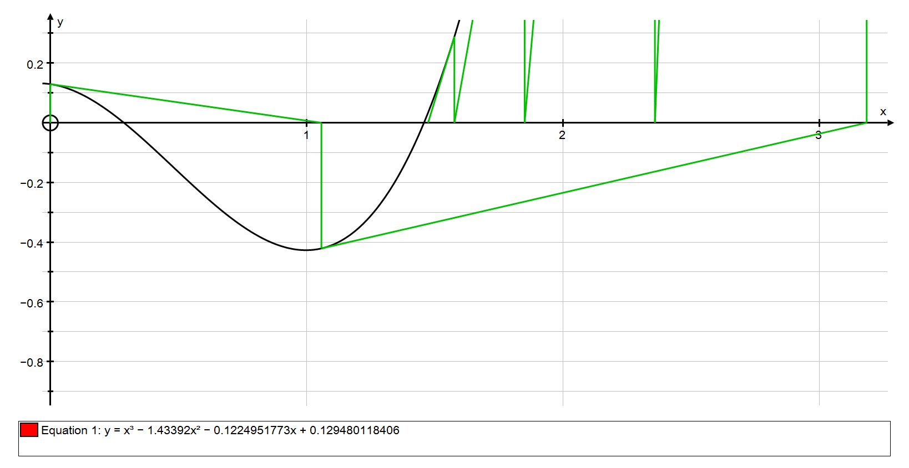

**Tangent to the curve at the point (, f ())**

**Tangent to the curve at the point (, f ())**

**Tangent to the curve at the point (, f ())**

**Tangent to the curve at the point (, f ())**

**The graph above shows that the sequence converges to the root in the interval [1, 2] instead of the root in the interval [0, 1]**

**Here it converges to the root in the interval [1, 2]; therefore the newton-raphson method has failed.** 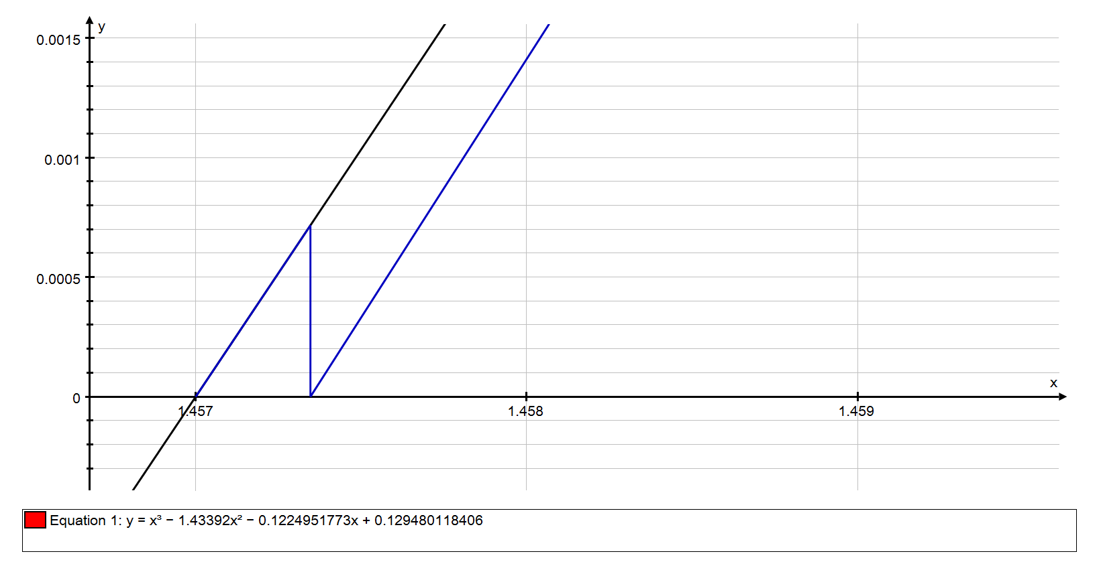

**Tangent to the curve at the point (, f ())**

**Tangent to the curve at the point (, f ())**

**Tangent to the curve at the point (, f ())**

**Tangent to the curve at the point (, f ())**

**The reason for the failure is that due to our starting estimate, , being close to a turning point of y = f(x). The result of this is that f’(x) is quite small which in turn results in a large value for which in most cases means that it is not close to the root which we intended to find. This concludes with our values converging to a root, but not the root that we intended to find.**

**Fixed Point Iteration – Rearrangement Method**

**A second iteration method is the rearrangement method where the first step is to rearrange the function into the form. Any value of x for which x = g(x) is a root of the original equation.**

**I will use the function .**

**Therefore,**

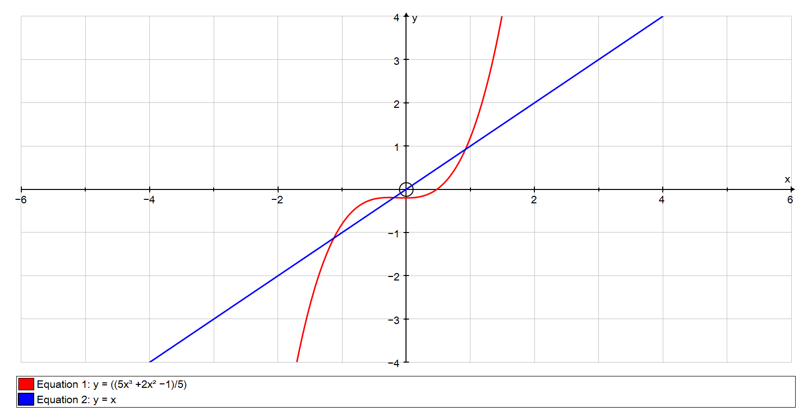**Below is a graph of the function g(x) and the line, y = x.**

I will be looking for this root of the original equation.

I will be looking for this root of the original equation.

The points where the curve and the line intersect are the roots of the original equation.

The points where the curve and the line intersect are the roots of the original equation.

**To find the root in the interval [-1, 0], we again need an estimate for the root. I will choose the nearest approximate so that .**

**In this method, we must find a value for x such that**

**A requisite to use this method, however, is that -1 < g’(x) < 1**

**So, using our starting point of and putting into g’(x), we get the following:**

**= 0 and -1< 0 < 1 therefore, we can find the root.**

**Now, using the equation: we see that when using out initial value for x, , the left hand side (LHS) is equal to 0 whereas the right hand side (RHS) is equal to**

**=**

**Therefore, our new approximation for x is i.e. = -0.2**

**Using this new value of x, we continue using the method so that:**

**LHS = RHS = = -0.192 meaning that**

**We continue doing this until we get x = g(x) which is shown in the table below.**

|  |  |
| --- | --- |
| **x** | **g(x)** |
| **0** | **-0.2** |
| **-0.2** | **-0.192** |
| **-0.192** | **-0.192332288** |
| **-0.192332288** | **-0.192318016** |
| **-0.192318016** | **-0.192318629** |
| **-0.192318629** | **-0.192318602** |
| **-0.192318602** | **-0.192318603** |
| **-0.192318603** | **-0.192318603** |
| **-0.192318603** | **-0.192318603** |

**Here, we can see that following the method has led us to the root, x = 0.19232 to 5 s.f.**

**The gradient of the graph at the root x = 0.19232 is**

**Below is a visual representation of how this iterative formula works.**

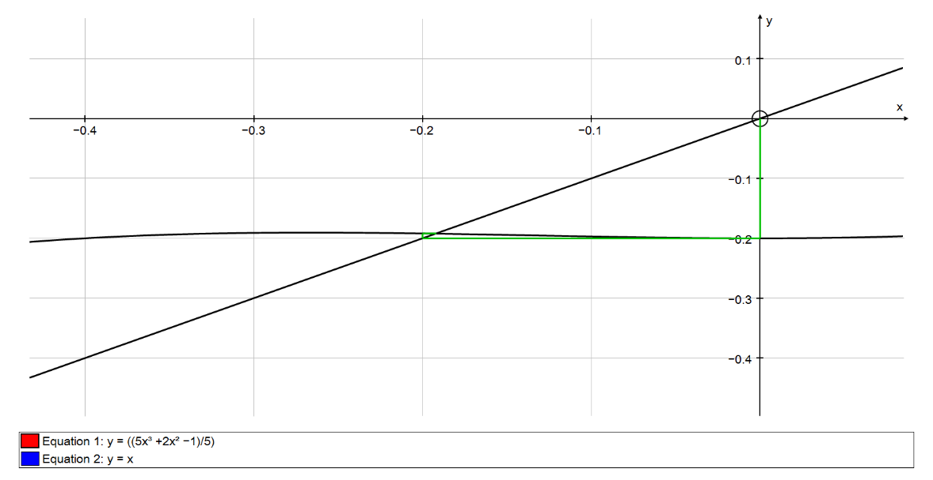

Curve g(x)

Horizontal line to y = x

Line y = x

Vertical line to curve g(x) from the point

**Zooming into the graph, we see that this pattern continues.**

Curve g(x)

Horizontal line to y = x

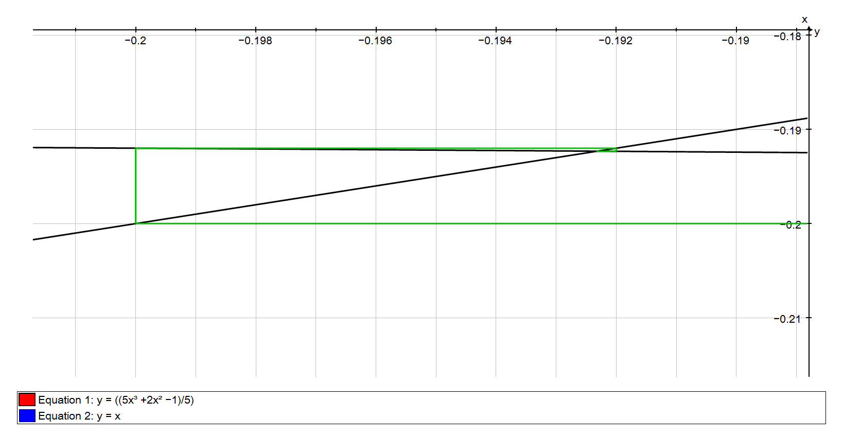**After numerous iterations, the pattern takes the form of a cobweb diagram and the process eventually narrows down and finds the root as seen in the graph below.**

Vertical line to curve g(x) from the point

Horizontal line to y = x

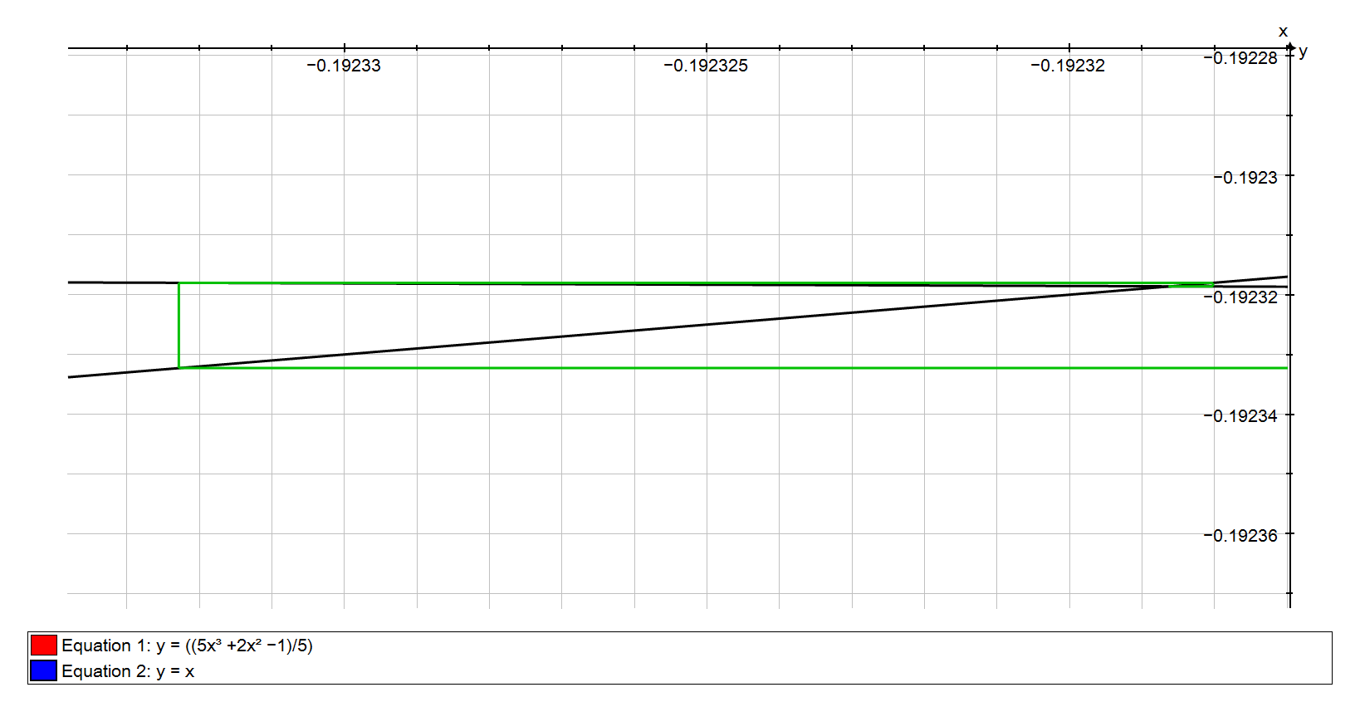

Vertical line to curve g(x) from the point

Horizontal line to y = x

Horizontal line to y = x

**Fixed Point Iteration – Rearrangement Method Failure**

**As pointed out earlier, a prerequisite for this method is that g’(x) must be greater than -1, but less than 1 i.e. -1 < g’(x) < 1**

**If g’(x) does not follow this rule, this method will fail as I will demonstrate below.**

**I will be using my previous function,**

**Rearranging this function once again to get x as the subject, we reach**

**= g(x)**

**Below is a graph of the function g(x) and the line, y = x.**

This time, I will be looking for this root of the original equation.

I will be looking for this root of the original equation.

**Since the root is in the interval [-2, -1] and close to -1, I will be using my starting point – my starting x value – as -1 i.e.**

**g’(x) of my starting value of -1 produces the following:**

**Since 2.2** is not less than 1, this means that this method fails as I will demonstrate.

Creating a table of values for x and g(x) as we did before with our starting value for x as -1, we see that this method did, in fact, find a root but not the root we were looking for.

|  |  |
| --- | --- |
| **x** | **g(x)** |
| **-1** | **-0.8** |
| **-0.8** | **-0.456** |
| **-0.456** | **-0.21164442** |
| **-0.21164442** | **-0.19156292** |
| **-0.19156292** | **-0.19235112** |
| **-0.19235112** | **-0.19231721** |
| **-0.19231721** | **-0.19231866** |
| **-0.19231866** | **-0.1923186** |
| **-0.1923186** | **-0.1923186** |

**Instead of finding the root in the interval [-2, -1], we see that this method has converged onto the root in the interval [-1, 0]. This indicates that the method has failed as we were unable to find the root we were looking for.**

**I will show the failure graphically below.**

Vertical line to curve g(x) from the point

Horizontal line to y = x

Curve

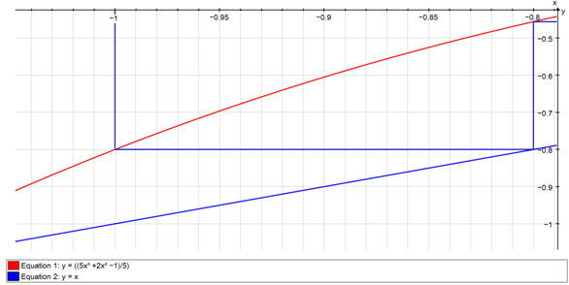

**A stair-case type pattern is formed and converges onto a root in the interval [-1, 0]**

**The graph below shows the pattern repeating.**

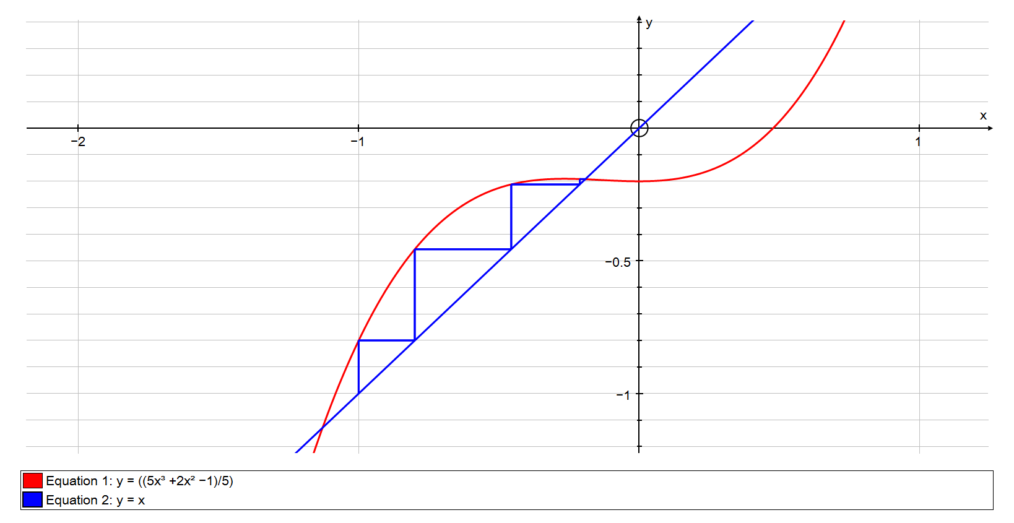

Vertical line to curve g(x) from the point

Horizontal line to y = x

Curve

**Comparison of All the Numerical Methods**

**To compare all the different numerical methods, I will be using the function that I have used previously in my explanation of how to solve an equation with the rearrangement method.**

**This function is:**

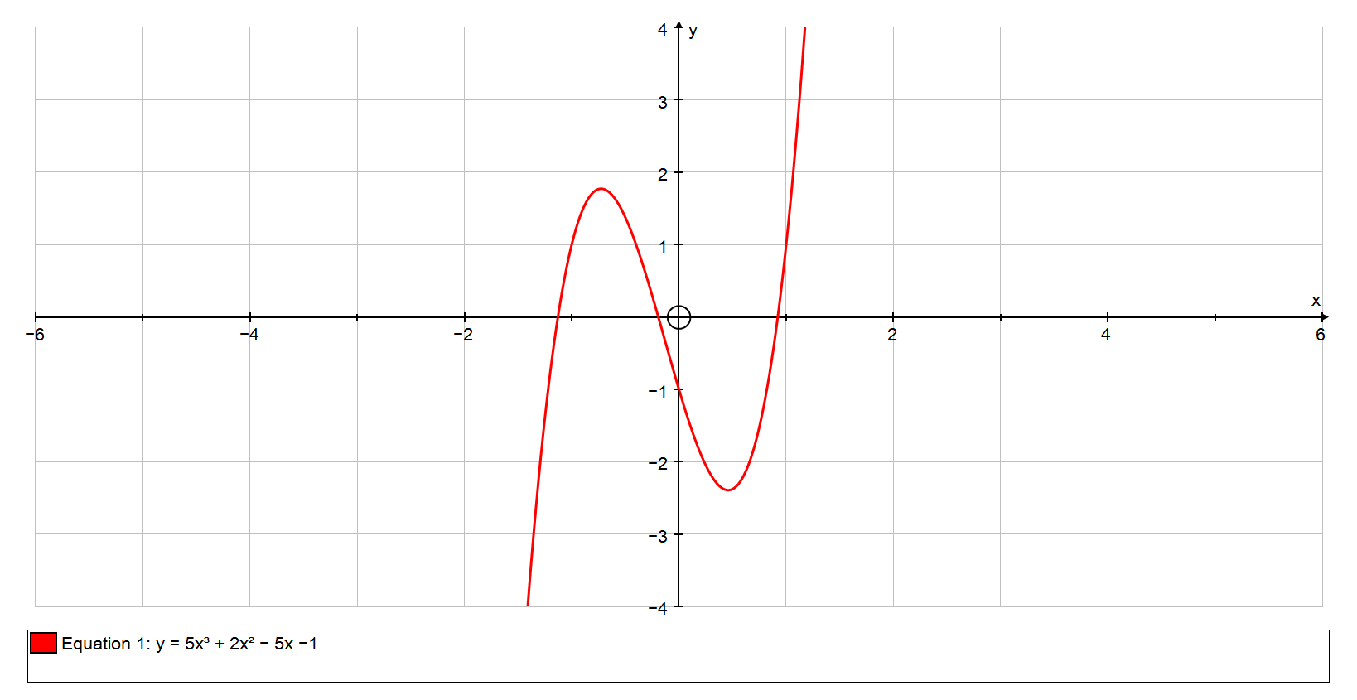 **The graph below shows this function.**

I will be finding this root.

**I will start with the change of sign – decimal search method. To compare, we need to find the same root as we did in the rearrangement method which is in the interval [-1, 0].The tables below show a sign change which indicates a root has been found in this interval.**

Curve f(x)

|  |  |
| --- | --- |
| **x** | **f(x)** |
| **-1** | **1** |
| **-0.9** | **1.475** |
| **-0.8** | **1.72** |
| **-0.7** | **1.765** |
| **-0.6** | **1.64** |
| **-0.5** | **1.375** |
| **-0.4** | **1** |
| **-0.3** | **0.545** |
| **-0.2** | **0.04** |
| **-0.1** | **-0.485** |
| **0** | **-1** |

Here we can see a clear sign change in the interval of [-0.2, -0.1].

The amount of iterations needed so far for this method is 10.

|  |  |
| --- | --- |
| **x** | **f(x)** |
| **-0.2** | **0.04** |
| **-0.19** | **-0.012095** |
| **-0.18** | **-0.06436** |
| **-0.17** | **-0.116765** |
| **-0.16** | **-0.16928** |
| **-0.15** | **-0.221875** |
| **-0.14** | **-0.27452** |
| **-0.13** | **-0.327185** |
| **-0.12** | **-0.37984** |
| **-0.11** | **-0.432455** |

A sign change has occurred again indicating that the root is in the interval [-0.2, -0.19].

The total amount of iterations needed so far is 11.

|  |  |
| --- | --- |
| **x** | **f(x)** |
| **-0.199** | **0.034799** |
| **-0.198** | **0.029596** |
| **-0.197** | **0.024391** |
| **-0.196** | **0.019184** |
| **-0.195** | **0.013976** |
| **-0.194** | **0.008765** |
| **-0.193** | **0.003553** |
| **-0.192** | **-0.00166** |
| **-0.191** | **-0.00688** |

Another sign change has appeared in the interval [-0.193, -0.192] so the root must be between one of these values.

The amount of iterations needed so far has increased to 19.

In the interval [-0.1924, -0.1923] there must be a sign change.

Therefore, our root to 5 significant figures is:

**X = -0.19235 ± 0.00005**

Where the ± 0.00005 is the error bound.

Overall, the change of sign – decimal search method needed 26 iterations for it to find the root to 5 significant figures with the error bound.

|  |  |
| --- | --- |
| **x** | **f(x)** |
| **-0.1929** | **0.003031** |
| **-0.1928** | **0.00251** |
| **-0.1927** | **0.001989** |
| **-0.1926** | **0.001467** |
| **-0.1925** | **0.000946** |
| **-0.1924** | **0.000424** |
| **-0.1923** | **-9.7E-05** |
| **-0.1922** | **-0.00062** |
| **-0.1921** | **-0.00114** |

**Continuing on and using the “Newton-Raphson” method, I will be using my initial x value, , as 0 seeing as the root we are trying to find is in the interval [-1, 0] and is close to 0.**

**However, to use the “Newton-Raphson” method, we must also find the differentiation of the function f(x).**

**Therefore:**

**So, our new x value is:**

|  |  |  |  |  |
| --- | --- | --- | --- | --- |
| **x** | **f(x)** | **f'(x)** | **New x** |  |
| **0** | **-1** | **-5** | **-0.2** |  |
| **-0.2** | **0.04** | **-5.2** | **-0.19230769** |  |
| **-0.19230769** | **-5.68958E-05** | **-5.21449704** | **-0.1923186** |  |
| **-0.1923186** | **-1.05321E-10** | **-5.21447774** | **-0.1923186** |  |
| **-0.1923186** | **0** | **-5.21447774** | **-0.1923186** |  |

**In 5 iterations, the “Newton-Raphson” method has converged onto the root in the interval [-1, 0].**

**The root produced to 5 S.F. is x = -0.19232** ± 0.000005

To confirm that this is indeed a root, we can check for a sign change.

Since a sign change has occurred, we have found one root of the function.

**Previously when using the rearrangement method for the same equation, it found the same root with 9 iterations.**

**After using each method on the same equation to find the same root, I am able to now compare both the ease-of-use and speed of convergence of each method. To demonstrate each method, I have used two pieces of software which were available to me: Autograph 3.3 and Microsoft Excel.**

**Autograph allowed me to produce a visual representation of what the graph of a function would look like which saved me substantial amounts of time in drawing the graphs myself and also gave me an insight into which intervals the roots resided in. In addition, the use of Autograph’s built-in functions greatly assisted me when demonstrating the iterative methods. Microsoft Excel saved me a considerable amount of trouble of having to work all the calculations when using all three methods and thereby saved me a lot of time.**

**The first method I used, the “Change of Sign – Decimal Search” method, is the easiest of the three methods to use because of the minimal amounts of mathematical knowledge needed to use the method. However, at the same time, this method also had the lowest speed of convergence as it took 26 iterations to reach the intended root which was 17 higher than that of the “Rearrangement” method and 21 higher than that of the “Newton-Raphson” method.**

**The second method I used, the “Newton-Raphson” method, is the one I believe to be the most efficient. This method’s speed of convergence is the highest out of the three as it took only 5 iterations to reach the intended root. I believe also that Autograph was especially helpful for this method as it allowed me to check if the initial starting point I had used would converge onto a root and helped me verify my calculations through the use of the software’s “Newton-Raphson” function. However, the ease-of-use of this method is lower than that of the decimal search method as you need some knowledge about differentiation.**

**The last method I used, the “Rearrangement” method, took 9 iterations to reach the intended root. This method, I believe, was not very easy to use out of the three as it: required knowledge of differentiation, required you to work out the intersection of a line and a curve and required you to know which roots you could find and which you could not. Therefore, the use of autograph when using this method was extremely useful as I was able to see which roots this method was able to find and which roots it could not and I was able to verify my calculations through the use of Autograph’s “x = g(x)” function**

**To conclude, with the use of Autograph, I believe that the Newton –Raphson method was the best out of the three as it was the most efficient when comparing the amount of iterations needed for the method to converge to a root and the amount of calculations needed. However, I believe that without Autograph, the “Change of sign – Decimal Search” method would be the best as it required simple mathematical knowledge and also the method’s ease-of-use was not as heavily affected by Autograph in comparison to the other two methods. Furthermore, although the speed of convergence for this method was the lowest, excel greatly reduced the tedium of the calculations for each iteration.**